**Batch: A1 Roll No.: 1911015**

**Experiment / assignment / tutorial No.**

**Grade: AA / AB / BB / BC / CC / CD /DD**

**Signature of the Staff In-charge with date**

|  |
| --- |
| **Title: Python Application Development** |

**AIM :** To develop a python application for a real world problem

**______________________________________________________________________**

**Expected OUTCOME of Experiment:**

**CO :**

**________________________________________________________________**

**Books/ Journals/ Websites referred:**

1.<https://stackoverflow.com/questions>

2. <https://www.geeksforgeeks.org/python-regex/>

3. <https://www.javatpoint.com/python-tkinter>

4.<https://www.w3schools.com/python/python_mysql_getstarted.asp>

**Github Link of Project files :**

https://github.com/shubhgosalia/Hotel-Management-System

**Problem definition:**

* To manage a huge property like a hotel is no easy task right from managing your staff, your rooms to handling customer needs and records.
* Manual work is never an option in such scenarios and it requires a proper management system to carry out daily operations.
* Thus, a hotel management system is an apt solution to this problem.

**Scope:**

* User can book/reserve a room given the room is available/unreserved
* Generate bill once booking is done
* User can filter out rooms as per his/her requirements i.e room type and availability of AC.
* Information regarding the rooms such as its type, pricing and availability status can be checked in a separate section. If room is booked, the record of the person who booked it is visible
* Rooms can be added via database connectivity
* Hotel status such as the no. of staff, available rooms, total customers is displayed and dynamically updated
* A section to reach out to the hotel in-charges is added

**Component diagram:**

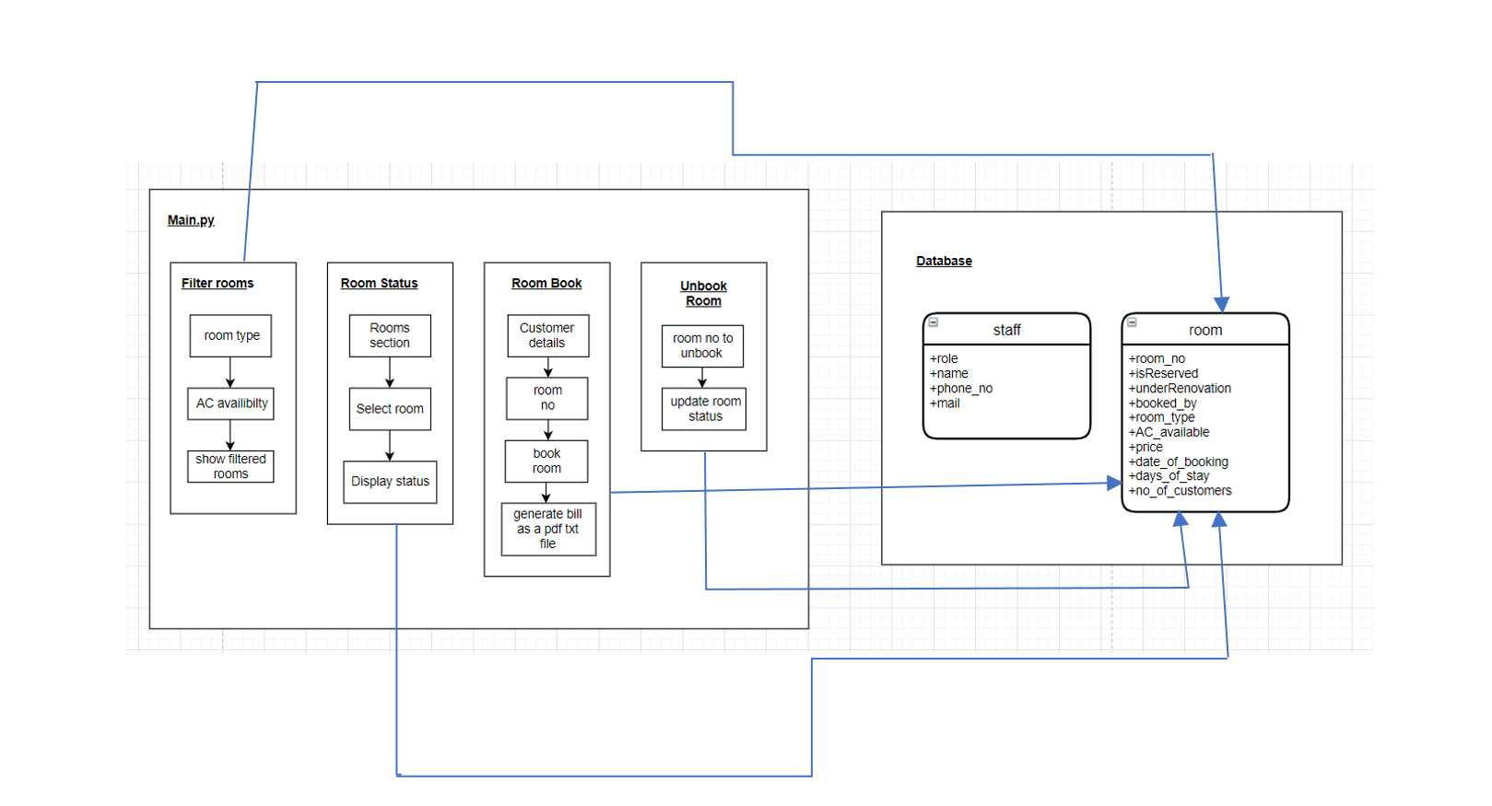

**API or package used**

* Tkinter Module:

1.) Message Box

2.) TTK with tkinter

3.) Combobox

* re module
* Regular expressions for checking phone number and email
* MySQLdb module
* Database Connectivity and Query Handling
* datetime module
* To show the room booking date by a customer, also printed on bill
* PIL module
* To display images
* os module
* To create txt files for bills

**Difficulties faced and measures taken to resolve:**

|  |  |
| --- | --- |
| **Implementation** | **By** |
| UI Design | Meet Gajra, Shubh Gosalia |
| Front-End | Meet Gajra, Shubh Gosalia |
| Database Design and Connectivity | Meet Gajra |
| Query Handling | Meet Gajra, Shubh Gosalia |
| Adding Frames and Filters with functionality | Shubh Gosalia |
| Hotel status and rooms Updation | Meet Gajra |
| Navigation Bar Functionality | Meet Gajra |
| Exception Handling | Shubh Gosalia |

**Team work (Contribution of each member).**